



**INTERUNIVERSITY MASTER OF SCIENCE IN MARINE AND LACUSTRINE SCIENCE AND MANAGEMENT**

**Are warming temperatures accelerating fish growth?**

**A case study of Common sole in North East Atlantic waters**

Kelly Sharlyn Diaz Diaz

December 2022

**Literature review**

Promotor: Prof. Dr. Marleen De Troch, UGent

Co-Promotor: Dr. Jochen Depestele, ILVO

Karen Bekaert, ILVO

Drs. Tuan-Anh Bui, UGent and ILVO

**Contents**

Description of the species: *Solea solea* 3

Description of the study area: Bay of Biscay 4

Temperature effects on fish 7

Description and utilization of otoliths 8

Previous studies on temperature and *S. solea* 10

Aims of this study 10

References 11

# Description of the species: *Solea solea*

*Solea solea*, also known as Common Sole, is a flatfish of the Pleuronectiformes order, that has an oval and asymmetric body (ICES, 2005). Both eyes are located on the right side of its body—hence, it is blind on the other side. Its dorsal fin starts on the dorsal profile of the head and meets the base of the caudal fin by a membrane that also connects to the anal fin. The pectoral fins are well developed on both sides of the body, with a black blotch on the distal end on the eyed side of the body. The common sole presents a grayish brown to reddish brown coloration with large and diffuse dark spots on the eyed side, while the blind side of the body is white (FAO, 2015). This fish is a demersal marine species, inhabiting sandy or muddy seabed with depths ranging from 0 to 200 m (FAO, 2015). They are found in the Eastern Atlantic, from southern Norway to Senegal; the Mediterranean Sea, including the Sea of Marmara; and the Black Sea (ICES, 2012).

Spawning of *S. solea* occurs in coastal waters –in areas within 30 m depth—and is triggered by the temperature of the water, resulting in variations in timing for the different geographical locations (FAO,2015; ICES, 2005). For instance, spawning happens between January and April in the Mediterranean; in the Bay of Biscay between December and May; and in the North Sea between April and June (FAO, 2015). The optimal temperatures for soles spawning are from 8 to 12 °C (FAO, 2015). Once fertilization occurs, the transparent eggs host embryos that will hatch at an early stage of development, with their mouths and pectoral fins still undeveloped. After a few days, these larvae change from idle individuals into actively swimming larvae with black eyes, and a well-developed mouth and pectoral fins (Fonds, 1979). Fonds (1979) found that the survival of *S. solea* eggs was influenced by the temperature of the water. He noted that, at temperatures between 10 and 16 °C, survival and hatch of eggs into swimming larvae was high; however, at 19 °C, at least 10% of the embryos hatched but many showed abnormalities, and at 22 °C there were no hatches at all. At optimum temperatures, the process from fertilization to swimming larvae of common sole lasts about 6 to 11 days (Fonds, 1979).

The survival of sole larvae can be influenced by factors such as temperature, food availability, predation, and transport to nurseries (Fonds, 1979). As juveniles, *S. solea* spend their first one to three years in shallow coastal areas and estuaries that play the role of nurseries, but they gradually move to deeper waters as they grow older (ICES, 2005). In those early years of life spent in nurseries, juvenile common soles go through a stage of fast growth—attaining growths of 11 cm after their first year (ICES, 2012). Fonds (1979) speculated that the timing and geographical location at which reproduction of *S. solea* occurs helps in the survival of the juveniles because it occurs: at a time when temperatures begin to rise, at locations close to nursery areas which will provide the demersal young sole with a rich food supply. As adults, *S.solea* are commonly 30 to 40 cm in length, but can reach sizes of 70 cm –they can also reach old ages such as 40 years (FAO, 2015; ICES, 2005; Vitale et al., 2019). Female adults of this species get to larger sizes than males and reach sexual maturity around four years old (FAO, 2015). At adulthood, soles feed mostly on polychaete worms, mollusks, and small crustaceans found in the sandy or muddy sea bottom they inhabit (ICES, 2005; FAO, 2015).

Because soles are found in sandy or muddy sea bottom, fisheries for *S. solea* use heavy gear to chase and catch this species in trawls (ICES, 2005). The demersal fishing gears allowed for capture of soles are 80 mm for beam trawling, and 90 mm for otter trawlers (ICES, 2012). Fixed nets are allowed with a requirement to utilize 100 mm mesh, although 90 mm are permitted since 2002 (ICES, 2012). The fishery for *S. solea* happens throughout the year with small peaks in spring and autumn. Soles tend to move toward deeper waters in cold winters, which makes them more vulnerable to offshore beamers during this season (ICES, 2012). In Europe, the areas with most activity for *S. solea* fishing are FAO Fishing Area 27 (Atlantic, Northeast), Area 34 (Atlantic, Eastern Central), and Area 37 (Mediterranean and Black Sea) (European Union, n.d.). For countries belonging to the European Union, the minimum landing size (MLS) is ≥ 24 cm of the fish’s total length; however, the MLS is ≥ 20.0 cm in Areas 37.1 (Western Mediterranean), 37.2 (Central Mediterranean), and 37.3 (Eastern Mediterranean) (European Union, n.d.).

# Description of the study area: Bay of Biscay

The Bay of Biscay is located west of France and north of Spain, and it is designated as Subarea 27.8 of the FAO Fishing Area 27 (Atlantic, Northeast) (European Commission, n.d.). Food and Agriculture Organization (FAO) Major fishing areas are arbitrary areas with boundaries determined in consultation with international fishery agencies trying to, as much as possible, overlap with areas already existing from other fishery commissions (FAO, n.d.). In the case of the Bay of Biscay, it can also be referred to as division VIII according to the International Council for the Exploration of the Sea (ICES) designation (Lassalle, et al., 2012). ICES fishing areas were first established in 1904, and they were originally 20; however, as new international treaties were developed and management changed, the geographic boundaries of these areas were also modified (ICES, 2020). Following the FAO designation, the Bay of Biscay is likewise divided into smaller sections: North (Division 27.8.a), Central (Division 27.8.b), South (Division 27.8.c), Offshore (Division 27.8.d), West of Bay of Biscay (Division 27.8.e) (Figure 1) (FAO, 2022).

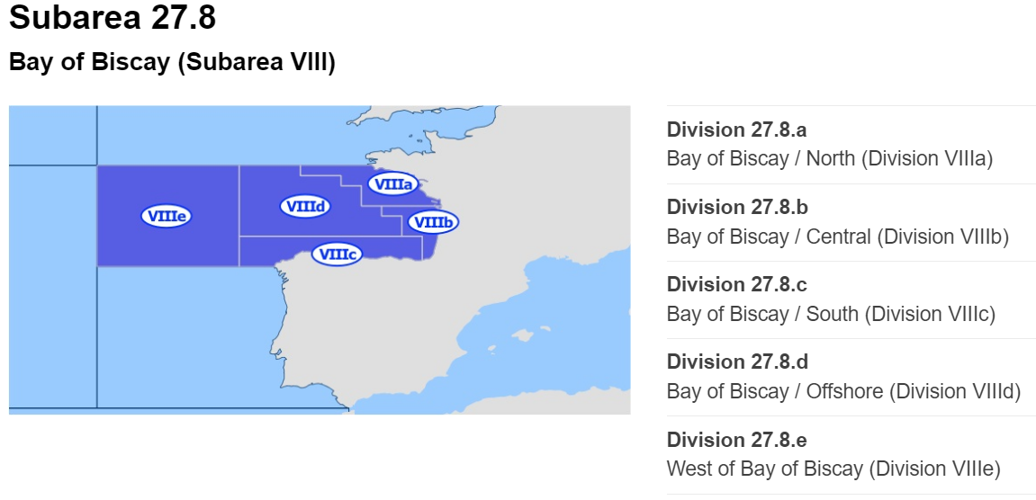

**Figure 1**. Map of the Bay of Biscay and its divisions, as defined by FAO Major Fishing Areas (European Commission, n.d.)

As a temperate area, the Bay of Biscay is characterized by seasonal mixing and stratification, but this pattern can be affected by wind-driven upwelling, river outflow, and tidal related processes (ICES, 2019). In other words, the Bay of Biscay is a complex mix between ocean features and local processes—including freshwater input from rivers (Costoya et al., 2015). In a study that analyzed the sea surface temperatures (SST) variability in the Bay of Biscay during the years 1982 to 2014, Costoya et al. (2015) found that, during that period, the warm season in this area has changed in length. They found that the SST pattern in this area: increases gradually from the northeast to the southwest from December to March; from May to August, the highest SST values were detected at the southeastern corner of the bay, with a transition occurring between both patterns in April; finally, the SST increased from north to south from September to November (Figure 2). However, Costoya et al. (2015) noted that the warm season in the Bay of Biscay starts between mid-June and the beginning of July, and ends between the end of September and the beginning of October (Table 1). This trend suggested that the warm season in this area prolongs one additional month, not due to warmer summers or milder winters, but due to the season starting earlier and ending later (Costoya et al., 2015). The winter mixed layer in the Bay of Biscay ranges from 140 to 270 meters deep, and colder winters result in a deeper depth of the mixed layer, favoring higher concentrations of nutrients in the surface, promoting spring blooms in the area (Costoya et al., 2014; Somavilla et al., 2009). However, Somavilla et al. (2009) suggested that an increase in the duration of the warm season makes the stratification of the water column occur closer to the surface. He sustained that this phenomenon complicates the supply of nutrients from deeper layers to the mixed layer, which decreases the availability of nutrients in the area.

**Table 1.** Monthly mean SST (°C) and trend (°C dec-1) values with their associated standard deviation for the whole Bay of Biscay over the period 1982-2014 (Costoya et al., 2015).

Additionally, the Bay of Biscay is influenced by Atlantic waters, which results in upwelling events in the summer, and even anomalous winter upwelling events (affected by winds); such events can alter the recruitment of commercially important species (ICES, 2019). Fish diversity in the Bay of Biscay consists of nearly 700 species of fish, and is dominated by sardine, anchovy, mackerel, horse mackerel, and blue whiting in the pelagic zone (Borja, et al., 2019; Costoya et al., 2014). Migratory species, such as tuna species (albacore and bluefin), appear during specific periods and feed on smaller pelagic fish (ICES, 2019). In the northern area of the Bay of Biscay, the more abundant species are anglerfish, megrim, and sole (Borja, et al., 2019). Fisheries in both the Bay of Biscay and the Iberian Coast are managed under the Common Fisheries Policy (CFP), with some fisheries managed by the North East Atlantic Fisheries Commission (NEAFC) as well as by coastal states (ICES, 2019).

Human activities such as fishing, shipping, tourism, land-based industry, and agriculture create pressure in the Bay of Biscay; consequently, the main stressors in this area are abrasion, nutrient and organic enrichment, extraction of species, and substrate loss (ICES, 2019). Another potentially important stressor is climate change. One of the effects of climate change is sea level rising, caused by thermal expansion of the oceans and melting of glaciers and ice caps (IPCC, 2001). Within the Bay of Biscay, the sea level rise is reported to be approximately 3.09 mm/year (Marcos et al., 2007). Climate change also has an impact on the rising of ocean temperatures: within the Bay of Biscay and the Iberian Coast ecoregion, temperatures are projected to increase by 1.5°C to 3.0°C above mean conditions from 2050 to 2099 (Figure 3) (ICES, 2019). A change in sea temperatures can affect fish community structures, increasing the abundance of some populations while decreasing others (Chust, et al., 2011). In their analysis, Somavilla et al. (2009) suggested that a higher number of extreme hot SST days also influences the stratification of the water column—in contribution to longer warm seasons.

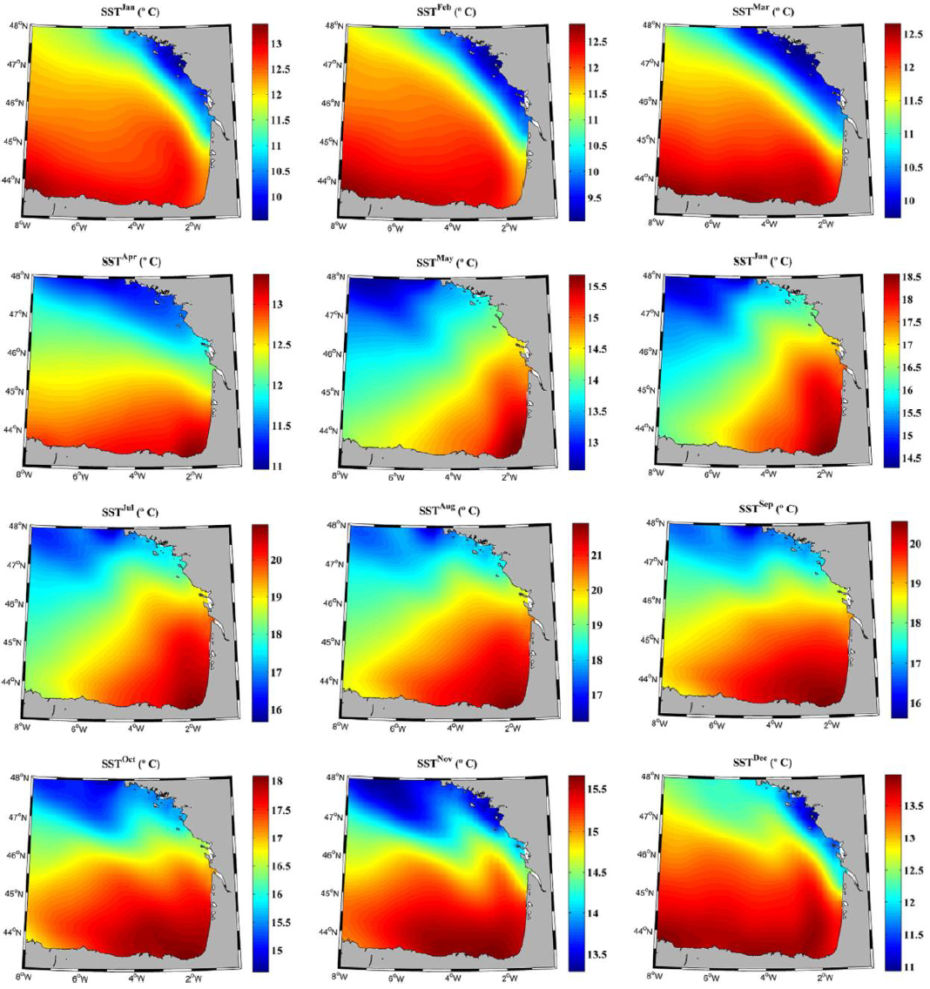

**Figure 2.** Monthly mean SST (°C) in the Bay of Biscay over the period 1982–2014 (Costoya et al., 2015).

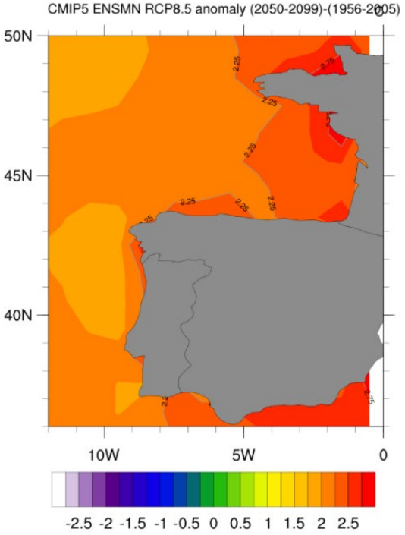

**Figure 3.** Difference in the mean climate in future period (2050–2099) compared to historical reference period (ICES, 2019).

# Temperature effects on fish

Changes in temperature can affect organisms’ biological processes, such as growth rates and sexual maturity (Baudron et al., 2013; Mollet et al., 2013). A well-known concept involving the influence of temperature in body growth is the Bergmann's rule, which explains that body size within a same species increases with latitude and colder climates; in other words, larger individuals are found at higher latitudes (Blackburn and Hawkins, 2004). According to this rule, when organisms inhabit areas of lower temperatures, they display slower growth, delayed maturation, and larger asymptotic sizes (Bergmann, 1847, as cited in Mollet et al., 2013). This can be explained by the benefits of lower surface to volume of larger body sizes when in colder environments, where the dissipation of thermal energy is costly; as well as the benefits of a higher surface to volume ratio of smaller body sizes when in warm environments, where the accumulation of surplus thermal energy is costly (Mollet et al., 2013).

Growth rates change naturally as the animal ages. Energy allocation changes after the individual reaches sexual maturation, the metabolic rate increases to fuel other activities such as thermoregulation, migration, and more significantly reproduction—consequently, growth rate is reduced (West et al., 2001). In addition to this, studies have shown that lower temperatures reduce developmental rates, which results in individuals with larger sizes at a given developmental stage—like metamorphosis or maturation; this effect is referred to as the temperature-size rule (Angilletta, 2008, as cited in Mollet et al., 2013). In other words, warming temperatures can mean faster growth rates for temperate fish, but with the downside of a smaller adult body size (Baudron et al., 2013). As such, we can see that warmer habitats can have a significant effect on the growth and development of species.

One of the effects of temperature in habitats involves oxygen supply and demand. For marine fishes and invertebrates, maximum body weight (MBW) is limited by energy demand and supply, for which a balance is reached when demand and supply are equal amounts—thus, net growth is zero (Cheung et al., 2012). Authors Pörtner & Knust (2007) stated that warmer temperatures increase the oxygen demand but decrease oxygen solubility; such an imbalance limits the animal's capacity to increase its aerobic metabolic rate above routine levels, thereby impairing individual performance. This thermal sensitivity is more severe for large body sizes, resulting in higher mortality among larger specimens compared to smaller ones (Pörtner & Knust, 2007). In this sense, in warmer temperatures individuals with smaller body sizes have the advantage of a reduced risk of oxygen deprivation (Baudron et al., 2013). The effect of temperature on individuals is only predicted to worsen over time: the maximum body weight of fishes is expected to shrink by 14-24% worldwide from 2000 to 2050 (Cheung et al., 2012).

Additional to body size, growth, and sexual maturation, temperature also affects the distribution of species (Perry et al., 2005). In a study performed on the North Sea, Perry et al. (2005) found that two-thirds of marine fish species had been shifting in mean latitude or depth in relation to warming for over 25 years—this trend was displayed by commercially exploited species such as the common sole (*Solea solea*) and also by non-targeted species (Perry et al., 2005). For instance, in the Bay of Biscay there have been reported changes in nursery areas of some flatfish, as well as an increase of deep-water species previously found further south (ICES, 2019). However, for fish populations that have limited dispersal capabilities or need specific habitat requirements, climate change could pose an even greater threat than to more flexible species (Perry et al., 2005). If temperatures continue to rise, this will have a profound impact on commercial fisheries due to continued shifts in the distribution and composition of species communities (Perry et al., 2005).

# Description and utilization of otoliths

Defining the exact age determination of fish is critical to have a deeper knowledge of their population dynamics: it provides the basis for further exploration on growth, mortality, recruitment, and other fundamental parameters (Holden & Raitt, 1974). A very useful tool in the study of the influence of temperature in fish are otoliths (Vitale et al., 2019). Otoliths are structures composed mainly of calcium carbonate (CaCO3) and are found in the inner ear cavity of all teleost fish (Campana, 1999; Rodríguez Mendoza, 2006). Teleost fishes have a bilateral pair of inner ears inside either side of the head, in that area there are three fluid-filled otolith organs— asteriscus, lapillus, and sagitta—each containing a dense calcified matrix, which is the otolith (Popper et al., 2003; Yedier et al., 2022). As fishes grow, their otoliths develop annulus, or rings, that can be used to determine the animal’s age; and although size and shape of otoliths vary greatly between species, they can be used to determine daily, seasonal, or annual growth patterns (Campana & Thorrold, 2001; Vitale et al., 2019). As the biggest of the three otolith types, sagittal otoliths are commonly used for otolith studies (Yedier et al., 2022).

There are three different preparation methods used to prepare the otolith for reading: the whole otolith method, the sectioned otolith method (some institutes stain the otoliths in this technique), and the break and burn method (Table 2) (ICES, 2010). After the otolith has been prepared, the rings can be counted and analyzed under a microscope (ICES, 2010). These rings form thanks to the composition of the otoliths: three crystal polymorphs of CaCO3—aragonite, calcite, and vaterite (Yedier et al., 2022). The appearance of the new rings will change according to their amount of organic material, varying from extremely opaque to completely transparent (Rodríguez Mendoza, 2006). The central and first zone is the nucleus of the otolith; after this, opaque zones in otoliths form during the period of greatest growth, and transparent zones occur during the period of slowest growth (Rodríguez Mendoza, 2006). New rings are visible first around the extremes of the otolith at the dorsal and ventral edges, and later they will be detectable entirely around the edge of the otolith (Vitale et al., 2019).

|  |  |
| --- | --- |
| Method | Description |
| Whole otolith method | Both otoliths (left and right) are placed in a container (black or transparent), filled with a clear fluid (water, oil, alcohol) or embedded in clear resin. |
| Sectioned otolith method | Otoliths are embedded in resin and sectioned through the nucleus. The thickness of the slides range from 0.5 - 0.6 mm, with some using a glass coverslip as well. |
| Break and burn method | The otolith is broken in half as close to the nucleus as possible. The broken halves are burnt until the translucent rings appear dark gray |

**Table 2.** Otoliths can be read using three different preparation methods (ICES, 2010).

In *S. solea,* a new annulus forms when the feeding season begins, which varies in timing among different areas, and it is considered that a single ring represents one year of growth (Figure 4) (Vitale et al., 2019). This fish species can reach ages of 40 years; due to this, high-powered optics and eyepieces are required for aging otoliths accurately because the stained rings get progressively narrower and closer to each other the farther they are from the nucleus (ICES, 2010; Vitale et al., 2019). Otoliths from *S. solea* need special considerations to keep in mind; for instance, otoliths of soles from different sea areas absorb the red stain differently and some might require water to leach out any excess stain (Vitale et al., 2019). Additionally, sole otoliths tend to present split and false rings (Fablet & Le Josse, 2005; Vitale et al., 2019). False rings appear as translucent zones within an opaque zone, while split rings appear as double structures, seemingly composed of two thin translucent bands (Panfili et al., 2002). It is important to recognize these misleading structures, since false rings can appear due to biological or environmental events—such as sexual maturity, environmental changes, etc.—and splits often occur in fish that live in sea areas, affected by a less active variation in water temperature between seasons (Fablet & Le Josse, 2005; Vitale et al., 2019). To prevent counting false rings and splits as a real annulus (which can overestimate the age of the fish), it is usually assumed that “true rings” go around the whole of the anterior edge of the otolith (Holden & Raitt, 1974).

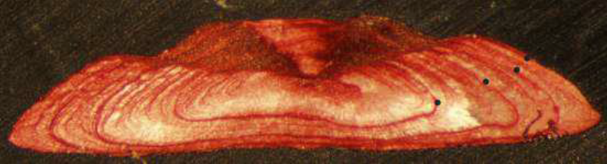

**Figure 4.** Sole otolith (estimated age: 4; month of capture: April; location: unknown). A wide nucleus and first growth zone can be seen, with a slowing down in growth in the final year (Vitale et al., 2019).

Accuracy when measuring otoliths is critical: underestimation of age results in overly optimistic estimates of growth and mortality rates, while overestimation of age gives an underestimation of growth (Vitale et al., 2019). Once measured, otolith sizes can be used to calculate the length of the fish at capture (Bolle et al., 2004). Otoliths might also help distinguish between local fish populations due to the ecological and morphological differences in otolith shape between fishes inhabiting different types of environments (Mérigot et al., 2006). Otoliths, however, might potentially present abnormalities, especially when they inhabit ecosystems polluted by heavy metals (Yedier et al., 2022). In a study on four flatfish species, Yedier et al. (2022) found that, when there is a difference in their crystal structures (aragonite, calcite, and vaterite), otoliths can become “abnormal” and become significantly larger and less dense than regular otoliths. They found that anomalies occurred more frequently in the otolith from the eyed side of the common sole compared to the blind side (Yedier et al., 2022). These irregularities can affect the inner ear and impair its two major sensory functions: balance and hearing; they can also hamper the accuracy to count age rings (Campana, 1999; Popper et al., 2003; Yedier et al., 2022).

# Previous studies on temperature and *S. solea*

Several studies have explored the influence of temperature on *S. solea.* Fonds (1979) found that metamorphosis in common soles started earlier at high temperatures (19 °C), so soles from warmer areas would already be fully metamorphosed when compared to soles from areas with lower temperatures. He also found that warming temperature influences the beginning of the spawning season and has a negative effect on the survival of the eggs. In a different study, Fonds & Saksena (1977) found that smaller soles showed a maximum daily food intake at high temperatures (26° C), while larger soles ate more in areas with lower temperatures (14 to 16° C). They suggested that this phenomenon may explain why the young soles inhabit nursery areas in warm shallow coastal waters with a rich food supply, while adult soles find optimum conditions for growth at greater depths. In general, common soles seem to reach an equilibrium at 16° C (Fonds & Saksena, 1977). On the other hand, there have been reports of large catches of dead soles during severe winters, evidencing the effects of prolonged extremely low temperatures (below 3ºC) on *S. solea* (ICES, 2005).

Mollet et al. (2013) found that populations of *S. solea* from northern colder environments (Irish Sea and North Sea) had higher rates of energy acquisition and reproductive investment, as well as smaller asymptotic sizes than southern populations from warmer environments (Bay of Biscay). They also reported that soles from northern areas showed a tendency to mature earlier than southern soles; because of this, the growth rate of north populations of soles was higher before sexual maturation, and lower after maturation (Mollet et al., 2013). Variations in body size are particularly important for *S. solea* because this species displays sexual size dimorphism, with female adults reaching larger sizes than males (FAO, 2015; Rijnsdorp et al., 2010). Mating behaviors include size-assortative preference, and with warming temperatures resulting in smaller body sizes, the probability of finding mates within the preferred size range decreases greatly; consequently, the species becomes more (Rijnsdorp et al., 2010).

# Aims of this study

This thesis will focus on studying if the Temperature size rule (TSR) applies to the Common sole (*Solea solea)* from the Bay of Biscay, Divisions 27.8.a (North) and 27.8.b (Central). In order to do this, it is necessary to study the measurements of otolith rings from soles captured in this area during the period 1989-2020, which will be obtained from the archives of Flanders Research Institute for Agriculture, Fisheries and Food (ILVO). The measurements will then be used in contribution to sea bottom temperature data, collected from the Inter-Sectoral Impact Model Intercomparison Project (ISIMIP), to detect the influence of temperature in *S. solea* growth.

# References

Angilletta Jr., M. J. (2009). Thermal Adaptation: A Theoretical and Empirical Synthesis. doi: https://doi.org/10.1093/acprof:oso/9780198570875.001.1

Baudron, A. R., Needle, C. L., Rijnsdorp, A. D., & Tara Marshall, C. (2013). Warming temperatures and smaller body sizes: synchronous changes in growth of North Sea fishes. *Global Change Biology, 20*(4), 1023–1031. doi:https://doi.org/10.1111/gcb.12514

Bergmann, C. (1847). *Über die Verhältnisse der Wärmeökonomie der Thiere zu ihrer Größe.* Göttinger Studien.

Blackburn, T., & Hawkins, B. (2004). Bergmann’s rule and the mammal fauna of northern North America. *Ecography, 27*(6), 715–724. doi:https://doi.org/10.1111/j.0906-7590.2004.03999.x

Bolle, L., Rijnsdorp, A., van Neer, W., Millner, R., van Leeuwen, P., Er, A., . . . Ongenae, E. (2004). Growth changes in plaice, cod, haddock and saithe in the North Sea: a comparison of (post-)medieval and present-day growth rates based on otolith measurements. *Journal of Sea Research, 51*(3-4), 313–328. doi:https://doi.org/10.1038/nclimate1691

Borja, A., Amouroux, D., Anschutz, P., Gómez-Gesteira, M., Uyarra, M., & Valdés, L. (2019). *World Seas: an Environmental Evaluation, Chapter 5 - The Bay of Biscay* (Second Edition ed.). (C. Sheppard, Ed.) Academic Press. doi:https://doi.org/10.1016/b978-0-12-805068-2.00006-1

Campana, S. (1999). Chemistry and composition of fish otoliths: pathways, mechanisms and applications. *Marine Ecology Progress Series, 188*, 263–297. doi:https://doi.org/10.3354/meps188263

Campana, S., & Thorrold, S. (2001). Otoliths, increments, and elements: keys to a comprehensive understanding of fish populations? *Canadian Journal of Fisheries and Aquatic Sciences, 58*, 30–38. doi:https://doi.org/https://doi.org/10.1139/f00-17

Cheung, W., Sarmiento, J., Dunne, J., Frölicher, T., Lam, V., Deng Palomares, M., . . . Pauly, D. (2012). Shrinking of fishes exacerbates impacts of global ocean changes on marine ecosystems. *Nature Climate Change, 3*, 254–258. doi:https://doi.org/10.1038/nclimate169

Chust, G., Borja, Á., Caballero, A., Irigoien, X., Moncho, R., Marcos, M., . . . Valencia, V. (2011). Climate change impacts on coastal and pelagic environments in the southeastern Bay of Biscay. *Climate Research, 48*, 307–332. doi:https://doi.org/10.3354/cr00914

Costoya, X., deCastro, M., Gómez-Gesteira, M., & Santos, F. (2014). Mixed Layer Depth Trends in the Bay of Biscay over the Period 1975–2010. *PLOS ONE, 9*(6), e99321. doi:https://doi.org/10.1371/journal.pone.0099321

Costoya, X., deCastro, M., Gómez-Gesteira, M., & Santos, F. (2015). Changes in sea surface temperature seasonality in the Bay of Biscay over the last decades (1982–2014). *Journal of Marine Systems, 150*, 91–101. doi:https://doi.org/10.1016/j.jmarsys.2015.06.002

European Commission. (n.d.). Area 27 – Atlantic, Northeast. [Online IMAGE]. Retrieved 12 1, 2022, from https://fish-commercial-names.ec.europa.eu/fish-names/area_en?code=27

European Union. (n.d.). *Solea solea*. Retrieved from Commercial Designations; European Commission: https://fish-commercial-names.ec.europa.eu/fish-names/species_en?sn=34099

Fablet, R., & Le Josse, N. (2005). Automated fish age estimation from otolith images using statistical learning. *Fisheries Research, 72*(2-3), 279–290. doi:https://doi.org/10.1016/j.fishres.2004.10.008

FAO. (2015, March 16). *Cultured Aquatic Species Information Programme: Solea solea (Linnaeus 1758)*. (R. Colen, A. Ramalho, F. Rocha, & M. Dinis, Editors) Retrieved from Food and Agriculture Organization of the United Nations, Fisheries and Aquaculture: https://www.fao.org/fishery/en/culturedspecies/solea_spp/en

FAO. (2021). *FAO Yearbook. Fishery and Aquaculture Statistics 2019/FAO annuaire. Statistiques des pêches et de l’aquaculture 2019/FAO anuario. Estadísticas de pesca y acuicultura 2019.* Rome, Italy: FAO. doi:https://doi.org/10.4060/cb7874t

FAO. (2022). *FAO Major Fishing Areas: ATLANTIC, NORTHEAST (Major Fishing Area 27)*. Retrieved from FAO Fisheries and Aquaculture: https://www.fao.org/fishery/en/area/27

FAO. (n.d.). *Main water areas*. (Food and Agriculture Organization of the United Nations) Retrieved December 14, 2022, from Coordinating Working Party on Fishery Statistics (CWP): https://www.fao.org/cwp-on-fishery-statistics/handbook/general-concepts/main-water-areas/en/

Fonds, M. (1979). Laboratory Observations on the Influence of Temperature and Salinity on Development of the Eggs and Growth of the Larvae of Solea solea. *Marine Ecology Progress Series, 1*, 91–99. doi:https://doi.org/10.3354/meps001091

Fonds, M., & Saksena, V. (1977). The daily food intake of young soles (Solea solea L.) in relation to their size and the water temperature. *Publications of the National Center for the Exploitation of the Oceans (CNEXO). Series: Proceedings of Conferences*(4), 51–58. Retrieved from https://archimer.ifremer.fr/doc/00305/41623/

Holden, M., & Raitt, D. (1974). *Manual of Fisheries Science. Part 2: Methods of Resource Investigation and their Application.* Rome, Italy: FAO. Retrieved from https://www.fao.org/3/F0752E/F0752E00.HTM#toc

ICES. (2005). *ICES FishMap: Solea solea.* Update and revision of the ICES Atlas of North Sea fishes. Retrieved from https://www.ices.dk/about-ICES/projects/EU-RFP/Pages/ICES-FIshMap.aspx

ICES. (2010). Report of the Workshop on Age Reading of North Sea (IV) and Skagerrak-Kattegat (IIIa) Plaice (WKARP). *ICES Expert Group Reports*, 6. doi: https://doi.org/10.17895/ices.pub.19280690

ICES. (2012). *Report of the Working Group on the Assessment of Demersal Stocks in the North Sea and Skagerrak (WGNSSK), 27 April - 3 May 2012.* doi:https://doi.org/10.17895/ices.pub.5338

ICES. (2019). *Bay of Biscay and the Iberian Coast Ecoregion – Ecosystem overview.* ICES Advice 2019: Ecosystem Overviews. doi:https://doi.org/10.17895/ices.pub.4666

ICES. (2020). *Definition and rationale for ICES ecoregions.* ICES Advice 2020, Ecoregions. Retrieved from https://doi.org/10.17895/ices.advice.6014

IPCC. (2001). *Climate Change 2001: Synthesis Report. A Contribution of Working Groups I, II, and III to the Third Assessment Report of the Integovernmental Panel on Climate Change.* (R. Watson, & Core Writing Team, Eds.) Cambridge, United Kingdom, and New York: Cambridge University Press.

Lassalle, G., Gascuel, D., Le Loc’h, F., Lobry, J., Pierce, G., Ridoux, V., . . . Spitz, J. (2012). An ecosystem approach for the assessment of fisheries impacts on marine top predators: the Bay of Biscay case study. *ICES Journal of Marine Science, 69*(6), 925–938. doi:https://doi.org/10.1093/icesjms/fss049

Marcos, M., Wöppelmann, G., Bosch, W., & Savcenko, R. (2007). Decadal sea level trends in the Bay of Biscay from tide gauges, GPS and TOPEX. *Journal of Marine Systems, 68*(3-4), 529–536. doi:https://doi.org/10.1016/j.jmarsys.2007.02.006

Mérigot, B., Letourneur, Y., & Lecomte-Finiger, R. (2006). Characterization of local populations of the common sole Solea solea (Pisces, Soleidae) in the NW Mediterranean through otolith morphometrics and shape analysis. *Marine Biology, 151*, 997–1008. doi:https://doi.org/10.1007/s00227-006-0549-0

Mollet, F. M., Engelhard, G. H., Vainikka, ,. A., Rijnsdorp, A., Ernande, B., & Laugen, A. (2013). Spatial variation in growth, maturation schedules and reproductive investment of female sole Solea solea in the Northeast Atlantic. *Journal of Sea Research, 84*, 109–121. doi:https://doi.org/10.1016/j.seares.2012.12.005

Moreira, F., Assis, C., Almeida, P., Costa, J., & Costa, M. (1992). Trophic relationships in the community of the upper Tagus estuary (Portugal): A preliminary approach. *Estuarine, Coastal and Shelf Science, 34*(6), 617–623. doi:https://doi.org/10.1016/s0272-7714(05)80066-6

Panfili, J., De Pontual, H., Troadec, H., & Wright, P. J. (2002). Otoliths. In J. Panfili, H. De Pontual, H. Troadec, & P. Wright, *Manual of Fish Sclerochronology* (p. 47). Brest, France: IFREMER-IRD. Retrieved from https://www.researchgate.net/publication/263104442_Types_of_calcified_structures_Otoliths

Perry, A., Low, P., Ellis, J., & Reynolds, J. (2005). Climate Change and Distribution Shifts in Marine Fishes. *Science, 308*(5730), 1912–1915. doi:https://doi.org/10.1126/science.1111322

Popper, A., Fay, R., Platt, C., & Sand, O. (2003). Sound Detection Mechanisms and Capabilities of Teleost Fishes. *Sensory Processing in Aquatic Environments*, 3–38. doi:https://doi.org/10.1007/978-0-387-22628-6_1

Pörtner, H., & Knust, R. (2007). Climate change affects marine fishes through the oxygen limitation of thermal tolerance. *Science, 315*(5808), 95–97. doi:https://doi.org/10.1126/science.1135471

Rijnsdorp, A. D., van Damme, C. J., & Witthames, P. R. (2010). Implications of fisheries-induced changes in stock structure and reproductive potential for stock recovery of a sex-dimorphic species, North Sea plaice. *ICES Journal of Marine Science, 67*(9), 1931–1938. doi:https://doi.org/10.1093/icesjms/fsq049

Rodríguez Mendoza , R. (2006). OTOLITHS AND THEIR APPLICATIONS IN FISHERY SCIENCE. *Croatian Journal of Fisheries: Ribarstvo, 64*(3), 89–102. Retrieved from https://hrcak.srce.hr/8984

Smoliński, S., Morrongiello, J., van der Sleen, P., Black, B., & Campana, S. (2020). Potential sources of bias in the climate sensitivities of fish otolith biochronologies. *Canadian Journal of Fisheries and Aquatic Sciences, 77*(9), 1552–1563. Retrieved from https://doi.org/10.1139/cjfas-2019-0450

Somavilla, R., González-Pola, C., Rodriguez, C., Josey, S., Sánchez, R., & Lavín, A. (2009). Large changes in the hydrographic structure of the Bay of Biscay after the extreme mixing of winter 2005. *Journal of Geophysical Research, 114*(C1), 1-14. doi:https://doi.org/10.1029/2008jc004974

Vitale, F., Worsøe Clausen, L., & Ní Chonchúir, G. (2019). Handbook of fish age estimation protocols and validation methods. *ICES Cooperative Research Reports (CRR), 346*. doi:https://doi.org/10.17895/ices.pub.5221

West, G., Brown, J., & Enquist, B. (2001). A general model for ontogenetic growth. *Nature, 413*(6856), 628–631. doi:https://doi.org/10.1038/35098076

Yedier, S., Bostanci, D., & Türker, D. (2022). Morphological and Morphometric Features of the Abnormal and Normal Saccular Otoliths in Flatfishes. *The Anatomical Record*, 1–16. doi:https://doi.org/10.1002/ar.25106